**1.Started minikube and status checked. Manifest File created for pod creation**

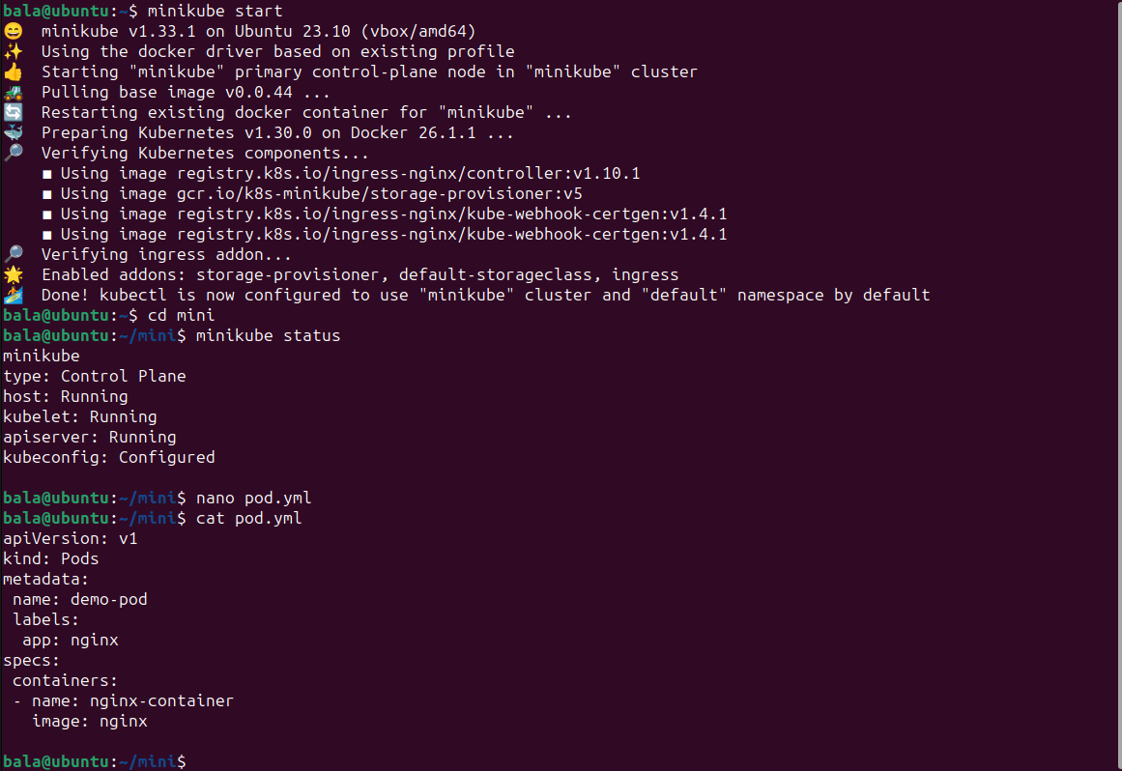

**2.Pods created by using manifest file & CLI**

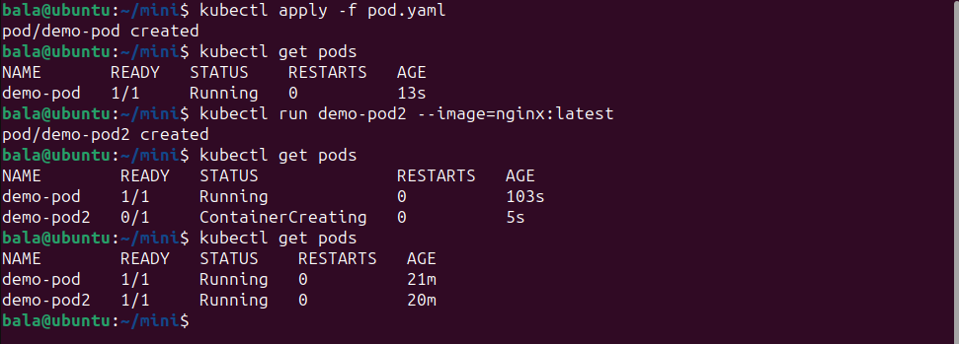

**And the created pods are running**

**3.Deployment created using manifest file, inside the namespace (demo-tasks)**

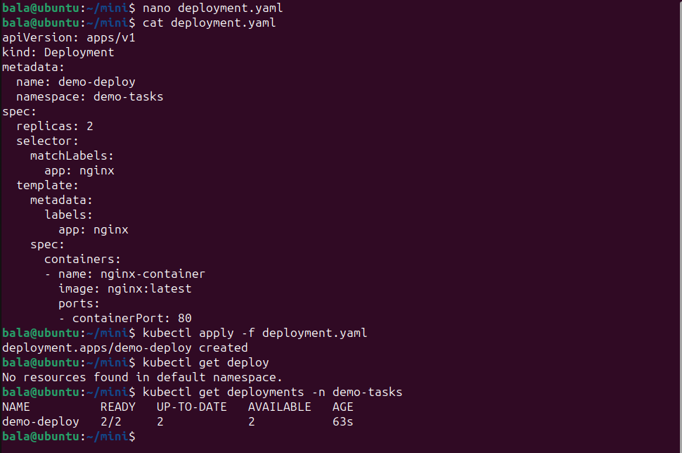

**4.Created replica pods are running inside the namespace(demo-tasks)**

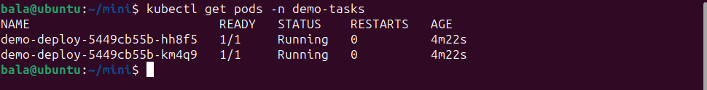

**5.Manifest file created for Service and Applied. Created service is Running inside namespace(demo-tasks)**

